VIDHYADEEP INSTITUTE OF BUSINESS ADMINISTRATION
BBA Department
Seminar Report

Ms. Dhara Gada Shah conducted a lecture named “Be the Author of Your Life” at Vidhyadeep Institute of Business Administration on 8th July, 2021. The goal of this seminar was to influence people’s attitudes and train the youth for a more inclusive and sustainable world. The structure of attitude was quickly described to the audience. It was structure of the attitude was as follows : Affects/Behaviour/Cognition. This programme has given us a fresh perspective on life and helped us to build new abilities for the workplace.
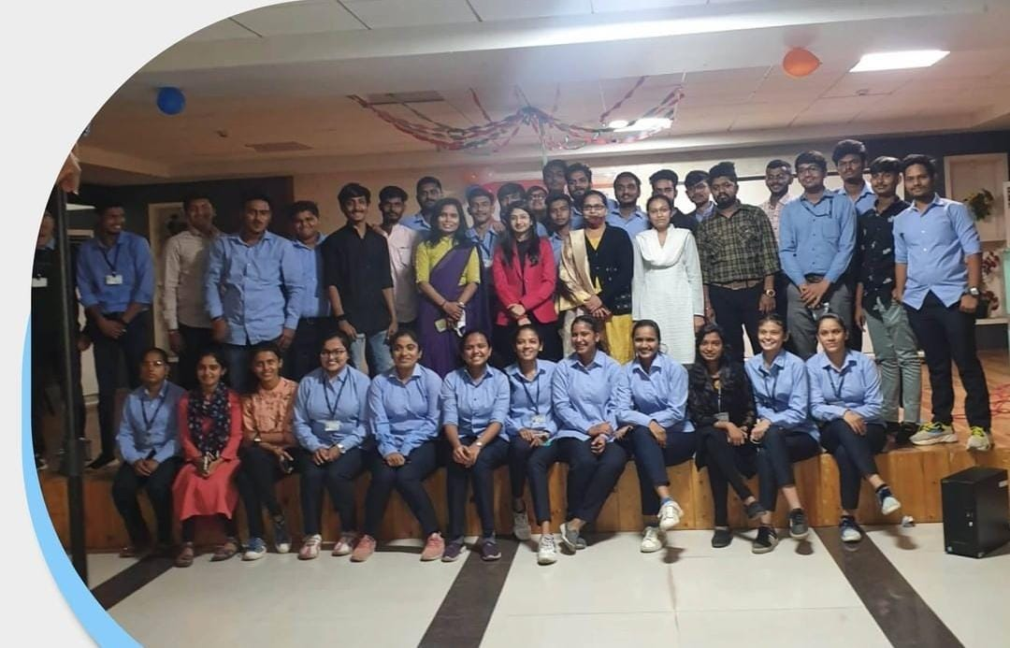

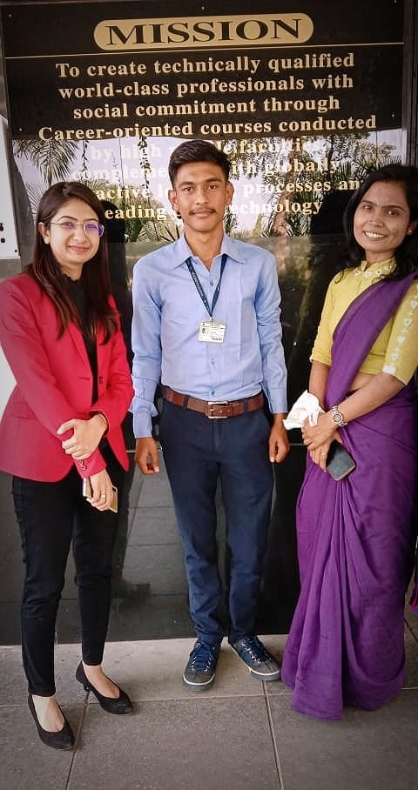

VIDHYADEEP INSTITUTE OF BUSINESS ADMINISTRATION
BBA Department

Due to COVID 19, No other activity has been done.

