VIDHYADEEP INSTITUTE OF BUSINESS ADMINISTRATION

BBA SPORTS REPORT (2021-2022)

Physical Education is an integral part of the total education system. It helps in the attainment of the ultimate aim of education i.e. the achievement of holistic development. Games and Sports play a vital role in the student’s life. A student should study hard to be successful in competitive examinations. But, he should also play games and sports to enjoy the health and vigour of life. Considering the concept of “SPORTS FOR ALL” throughout the entire session we organized Inter-department tournaments for students.

The following events have been organized for the inter-class sports tournaments for students:
- CRICKET
- VOLLEYBALL
- MUSICAL CHAIR
- CARROM
- KHOKHO
- TUG OF WAR
- KABADDI
- BADMINTON

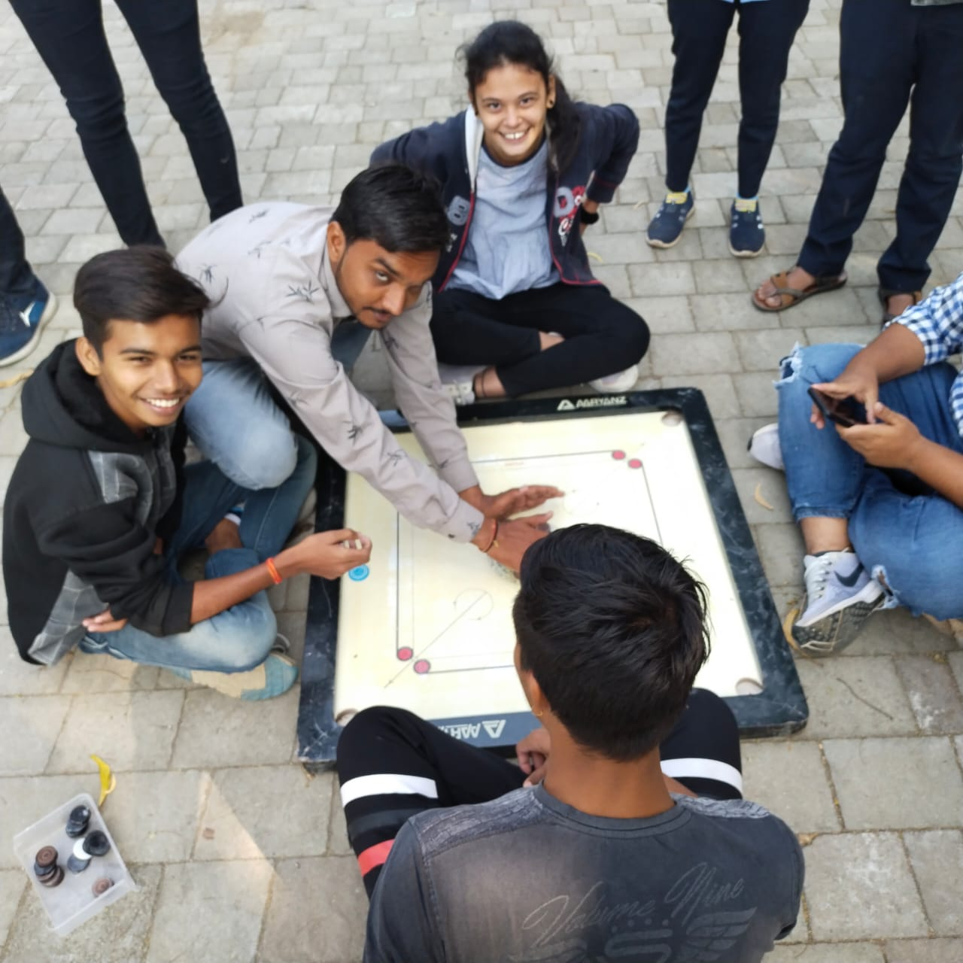

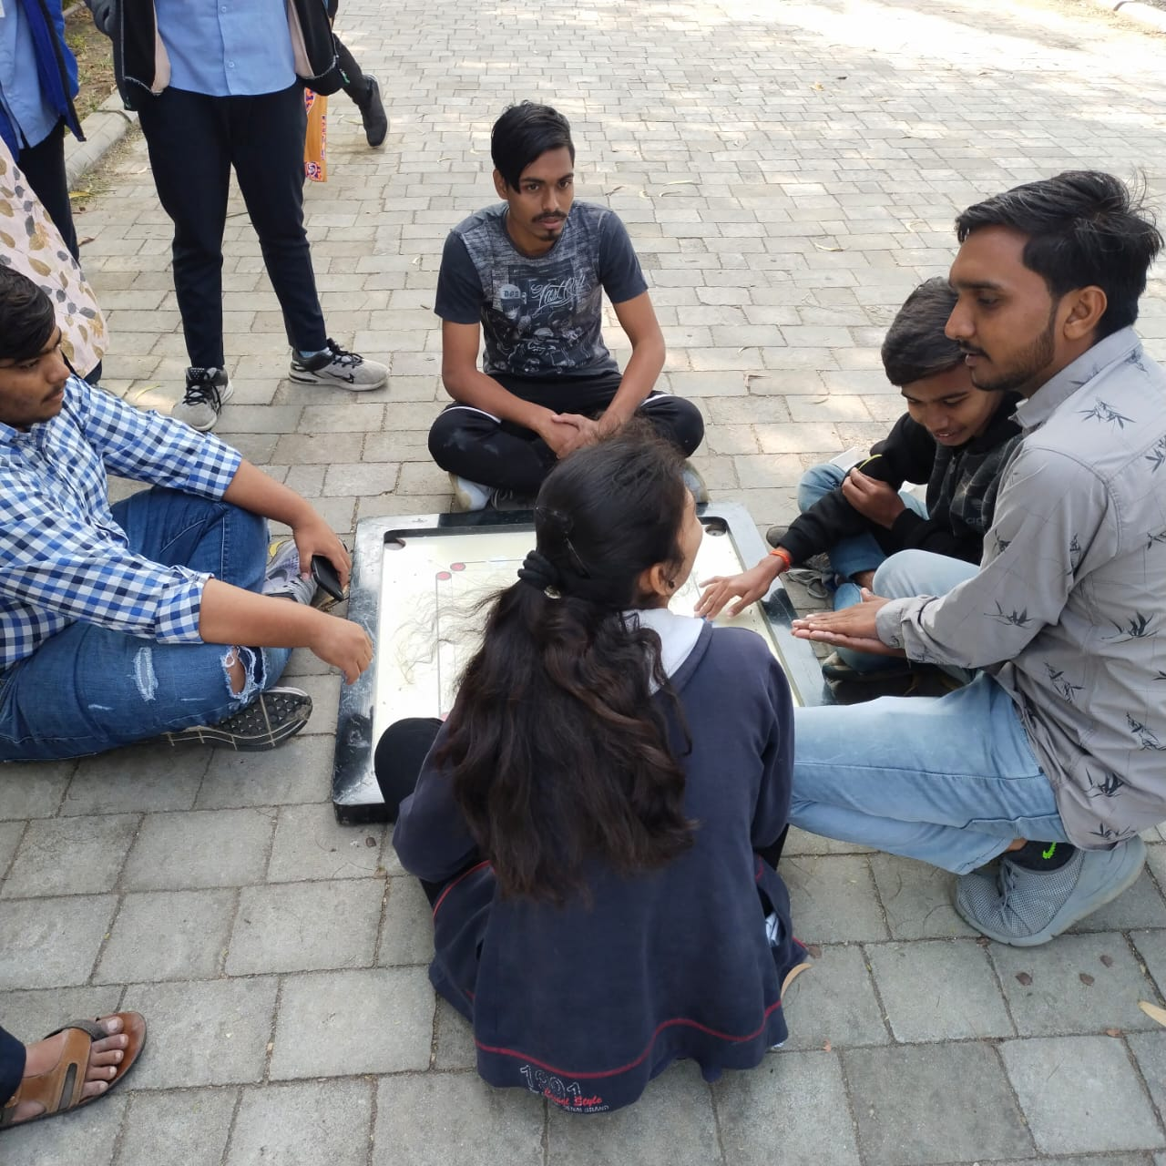

CARROM

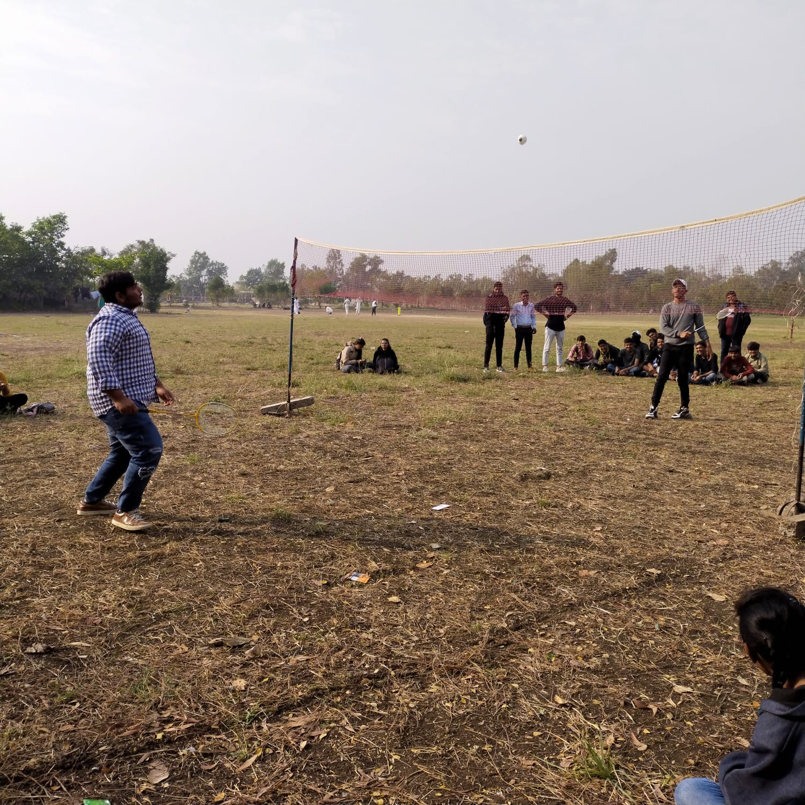
BADMINTON

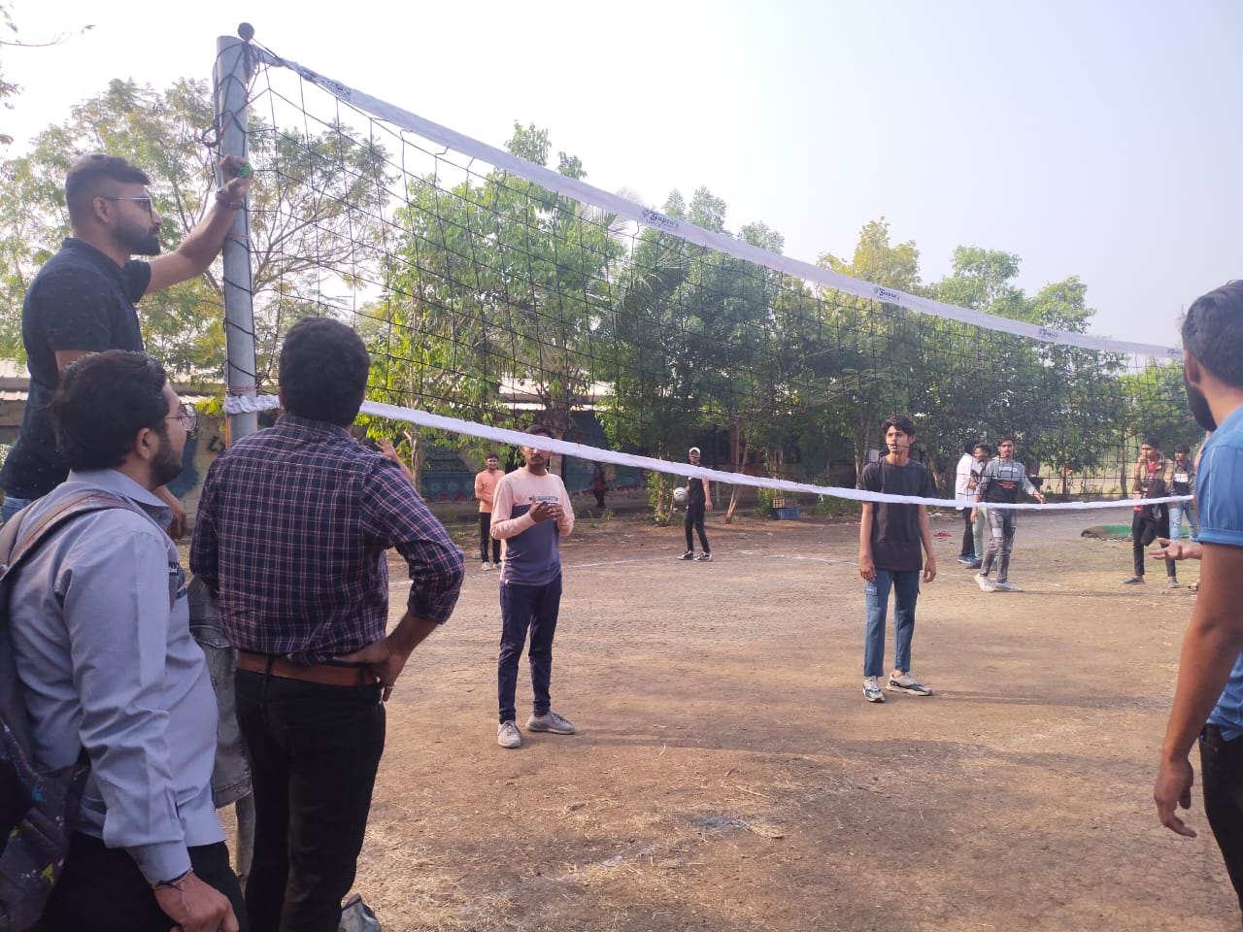

VOLLEYBALL

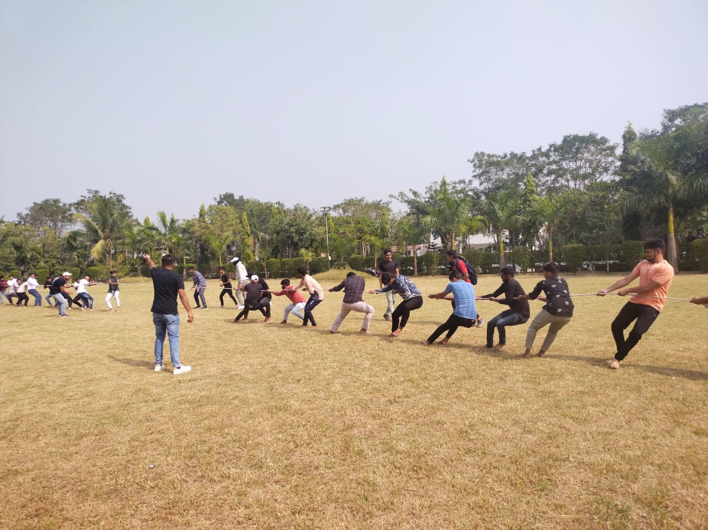

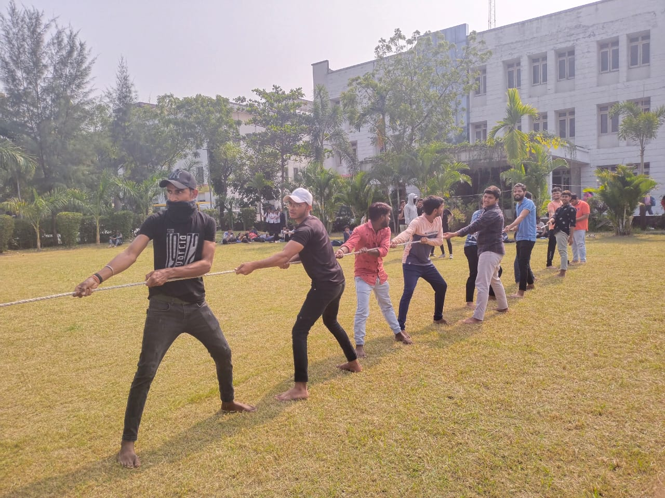

TUG OF WAR

