VIDHYADEEP INSTITUTES OF BUSINESS ADMINISTRAION, ANITA

WOMEN’S DAY CELEBTATION REPORT
For more than 100 years, the world has celebrated International Women's Day on March 8. Organizations, governments, charities, educational institutions, women groups and the media celebrate this day .This special day recognizes the advances made by women and girls all over the world. It is a day on which women, men, girls and boys come together to celebrate, show solidarity and recognize the dreams, aspirations and empowerment of women. International Women’s Day is an opportunity to commemorate the bravery of women in confronting injustice.

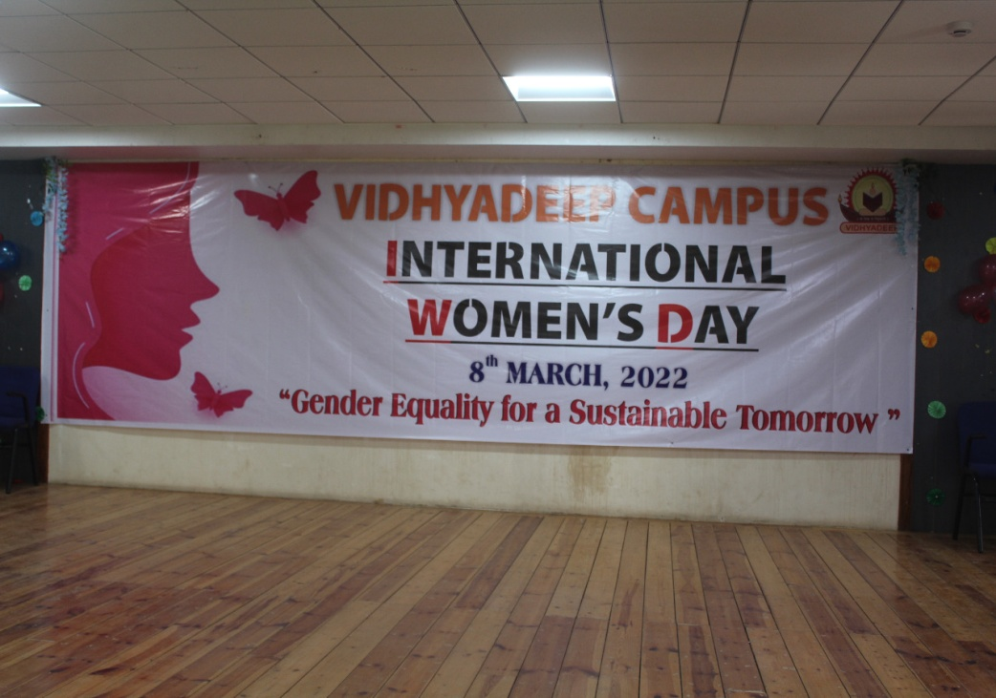

The women’s day celebrations details:
Topic:” GENDER EQUALITY FOR A SUSTAINABLE TOMORROW”.
Date: Tuesday, March 8th, 2022.
Time: 10:00 AM to 12:30 PM
Venue: Seminar Hall, VIBA College, Anita.

Thousands of events occur not just on this day but throughout MARCH to mark economics, political and social, cultural achievements of women. Many groups around the world choose different themes each year. Vidhyadeep campus choose “GENDER EQUALITY FOR A SUSTAINABLE TOMORROW”.

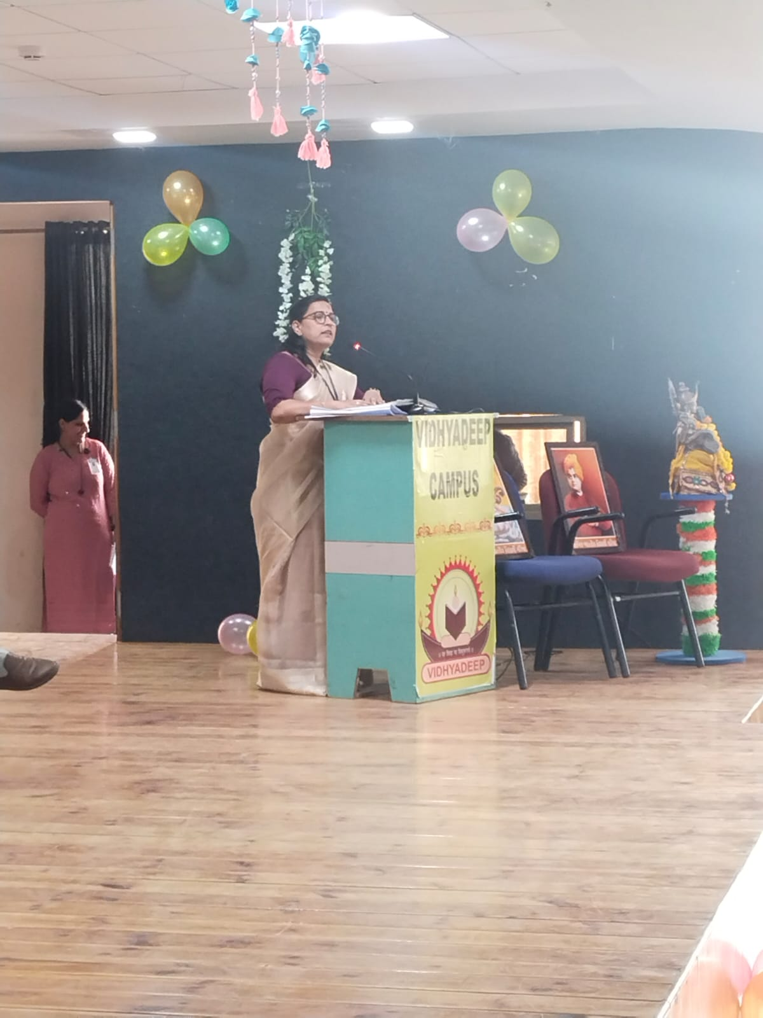 She is started programme for prayer
The program started with the lighting of lamp by respected Madam Principal of Mrs.Vrunda sule and Ms. Riddhi Bhavsar along with the Chief Guest, Dr.Sheetal Lathiya and Dr.Shivani Parikh. As per our tradition it was followed by reciting the prayer.

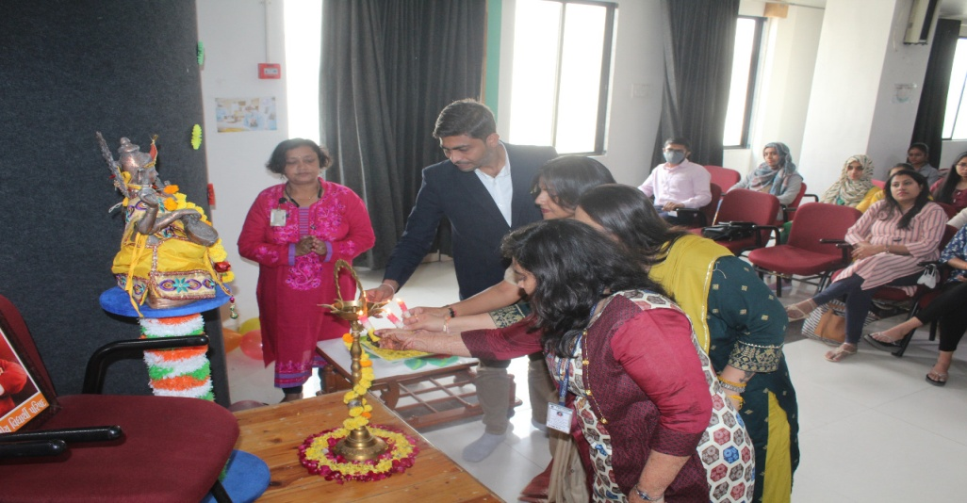

Lighting of lamp
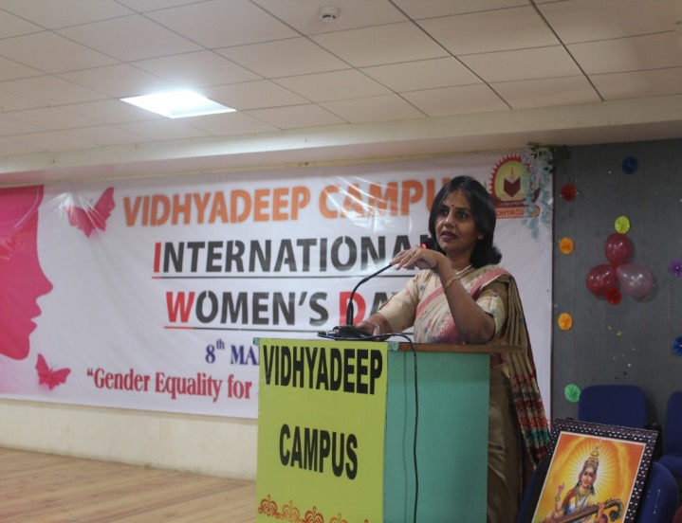
Welcome speech by Dr.Shivani Parikh Madam

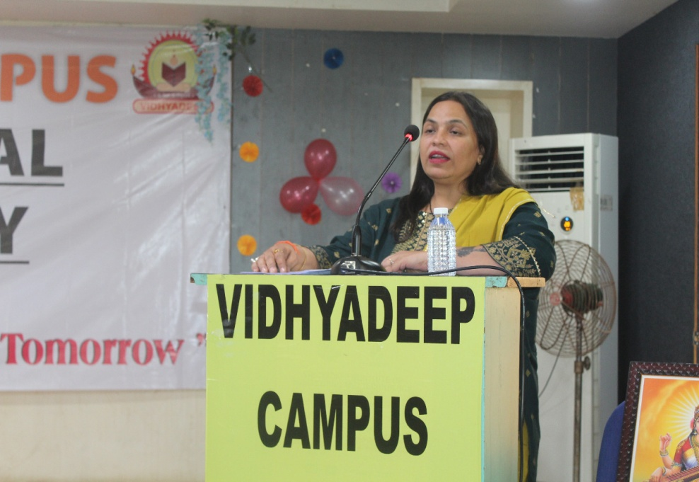

Welcome speech by Dr.Sheetal Lathiya Madam
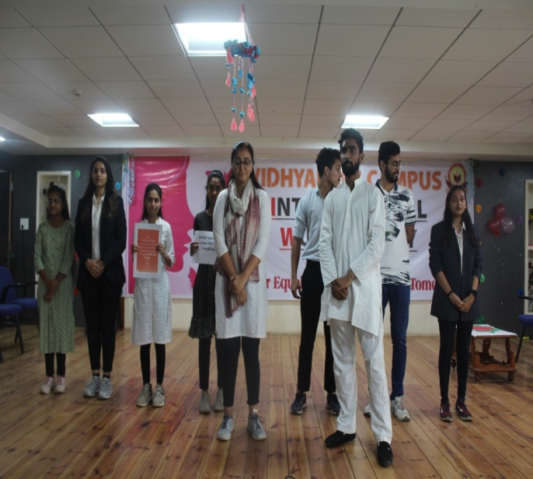
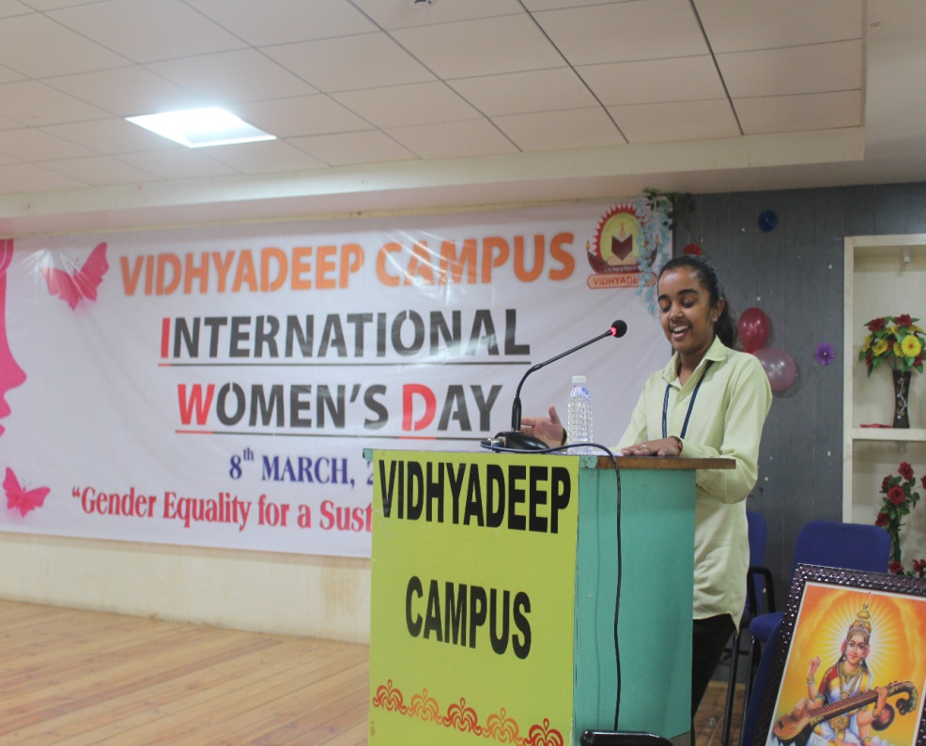

A drama performance by college Students give speech about women’s day

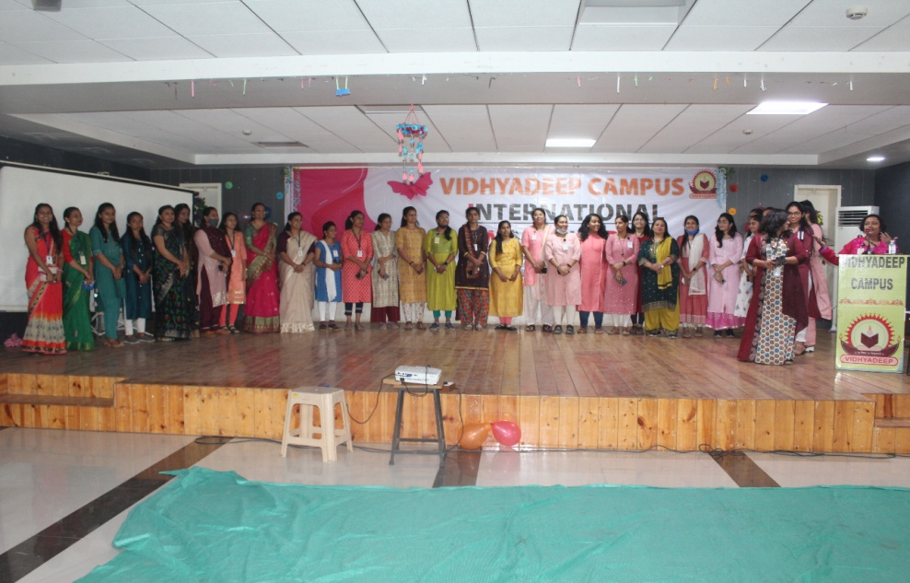

Our faculties

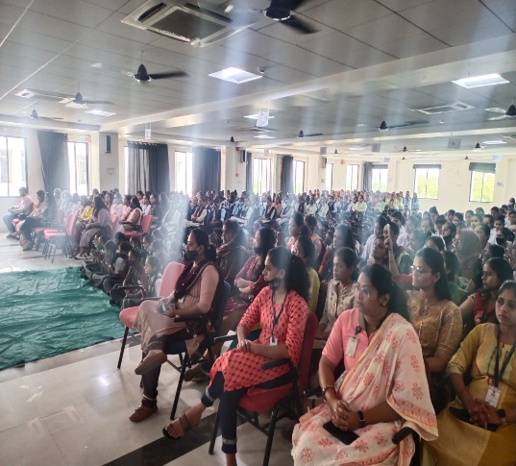

Report Prepared By:
Mrs.Nilofar Shaikh,

Vidhyadeep Womens’ Affinity Group,
VIBA College.

